PHYS 212 PreLab 8 Name ______________ ID_____________________

Impedance
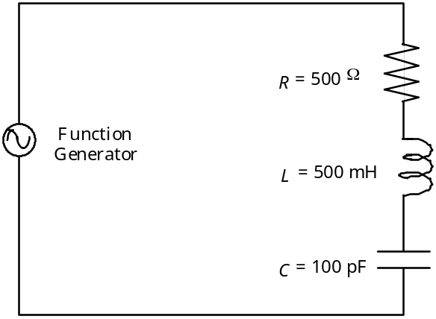
Figure 1. The series LRC circuit
Q1[9’] For the circuit of Figure 1 shown above, with R = 500Ω, C = 100 pF, and L = 500 mH, what are ω, XL, and XC at a frequency f = 15000 Hz? (pF=picoFarad=10⁻¹²F) Explicitly write down your calculations below.

ω = ________ [radians/sec]
XL = ________ [Ω]
XC = ________ [Ω]

Q2[9’] For the circuit of Figure 1, with R = 500Ω, C = 100 pF, and L = 500 mH, what is the impedance Z at a frequency f = 15000 Hz?

Z = ________ [Ω]

Resonance in an LRC Circuit
Q3[7’] For the circuit of Figure 1, with R = 500Ω, C = 100 pF, and L = 500 mH, what is the angular resonant frequency ωo?

ωo =________ [radians/sec]

Q4[2’] What is the resonance frequency fo?

fo =________ [cycles/sec]

The Quality of an LRC Circuit
Q5[7’] Using Equation 7, for the circuit of Figure 1, with R = 500Ω, C = 100 pF, and L = 500 mH, calculate the Q factor of the circuit.

Q = ________

Q6[4’] Using Equation 7, for the circuit of Figure 1, with R = 500 Ω, C = 100 pF, and L = 500 mH, what are the frequencies at the half power points f_{low} =fo -Δf/2 and f_{high}= fo +Δf/2?

f_{low} = ________ [Hz]
f_{high} = ________ [Hz]

Q7[12’] At resonance (f=fo), the RMS voltage VC across the capacitor is related to the Q factor and to the RMS voltage Vfg across the function generator by a very simple relation. Find this relation using what you know about the values of Q and Z at resonance. (Hint: drawing the phasor diagram can help). Show your work.

___________________________________________________________

